**CHAPTER 1**

**INTRODUCTION**

Monitoring is employed in various applications, including temperature, pressure, flow rate, capacity, acceleration, and so on. According to the quantities, distribution and detected frequency of the monitored objects, there are different monitoring methods to acquire the measurements.

**1.1 Introduction**

Several problems usually occur during the monitoring process of the temperature in a room. For example, a server room must be kept between 15 to 20 degree Celsius to monitor a temperature in or else the server might crash and can cause a loss of hundreds thousands. The temperature monitoring is widely used in various processes like in automotive industries, air conditioning, power plant and other industries that need the data to be saved and analyzed. Proposed design is to have the data acquisition system to measure and log some parameters. The main purpose of this system is to make it easy for the user to view the current temperature of the web based system. This research was developed to produce a prototype product of a Web Based Temperature Monitoring system that allows the user to continuously monitor the temperature condition of a room. The enhancement from the existing system on the temperature monitoring is that this prototype system allowed the data to be monitored anytime and anywhere from the Internet. This research development project was divided into two parts that involved with the hardware and software. The hardware part involved building the temperature sensor board and for the software part involved written programming and construct coding using C language program. The programs then are uploaded into the microcontroller which then use wi-fi application to display the temperature and saves the data into a database. And also publish the current temperature at the web browser.

Management has to choose either to place a person to monitor the temperature, or to save on human capital by developing a system that can monitor the temperature from other places at any given time. In order to solve the problem, the web-based temperature monitoring system that can be access anywhere and anytime through the Internet is build. With this system a user can remotely monitor the room temperature from anywhere which could save the human expenses. Web-Based Temperature Monitoring is one type of temperature recorder that monitors a temperature in a room and stores the data into a database and display the current temperature on the website through a web server. The system will continuously monitor the temperature condition of the room and the data can be monitored at anytime and anywhere from the Internet.

**1.2 Problem Statement**

Build a web-based system for monitoring temperature of different things. It measure the temperature of an application and stored that data into the database. Control temperature if exceeds threshold from remote area through website. Monitor and control temperature of different applications from remote area through website.

**1.3 Objectives**

**This system is developed to:**

1. Measure the temperature of an application.

2. Control temperature if exceeds threshold.

3. Monitor and control temperature of different applications from remote area through web.

In this chapter explain the introduction part, objectives and problem statement related to project, then next chapter2 describes previous researches and studies. All the requirements and development of system has described in chapter3.

**CHAPTER 2**

**LITERATURE SURVEY**

Temperature monitoring is employed in various applications, including temperature, pressure, flow rate, capacity, acceleration, and so on. According to the quantities, distribution and detected frequency of the monitored objects, there are different monitoring methods to acquire the measurements. A research has introduced by *S.L.Y.Youling* says, are mote wireless monitoring system applied in the building construction to get the concrete temperature in [1]. The system can be real–time and multi-regional access to information without the limits of distance between the monitored object and the monitor. This system consists of PC monitor and multi terminal and all the devices must be located within GSM and SMS network.

The system has two ways to access the information from remote terminals. First is using hand phone to check real-time monitoring information and second is to visit the PC monitor to access all monitoring information through the internet. Another research by *B.Yan and D.Lee* has elaborated that temperature monitoring will give a big impact on logistic management and production flow management. China is the leading country to implement the temperature monitoring for logistic such as production, storage, transportation, marketing and consumption. One example called a Cold Chain which is supply the chain system in temperature management. It ensures that the core requirements of maintaining low-temperature environment for the purpose of maintaining perishable goods quality, so it has higher requirements than the general logistics system at room temperature in [2]. Temperature changes will be recorded in the RFID tags with temperature sensors for the quality and meticulous, real-time management of the fresh products. In order to develop this we based proposed model, some comparison on previous project that similar with Web-Based Temperature Monitoring has been made. There are three different research projects selected and analyzed in order to get an idea that has been included in this project.

There is demand to monitor environmental parameters almost in all the industries and for research institutes. Analogue signal and wire communication systems are having many drawbacks. Especially in remote areas where mobile network is unavailable such as forests, deserts, mountains etc, wire communication is not suitable. The analogue data measurement requires manual effort to record and there may be a possibility of human error. Such type of systems fails to provide and store precise values of parameters. So, there is a requirement to do the remote place environmental parameters monitoring system which is to be accurate, easily operated, simple, small size, cost-effective and light weight. In present communication the wireless sensor (WS) in[3] data communication using LM35, ARM microcontroller, ZigBee module in[13], Arduino, Graphics LCD and PC was designed and developed. The temperature monitoring system with least number of components, less cost and less complexity has been constructed and tested. The slope of increasing temperature graph was 10.40 and of cooling 11.46. The graph shows that, the curves are having some hysteresis at the middle temperature range. The reason may be the ageing effect of the device or environmental factor effects.

Arduino Uno has mostly all the capabilities inbuilt and requires less hardware for its operation. Therefore, this makes it a perfect choice for remote parameter measurement system. Normally the sensors are linear and having high degree of accuracy. Using such type of experimental setup, sensor linearity and accuracy can be tested. Circuit complexity is less hence easy to understand. The main advantage of such system is that it was less expensive and one time investment hence it will be useful for many applications, where remote parameter measurement is needed. Also the system will be useful to test the device characteristics.

GSM based temperature monitoring system is a microcontroller based project in[1] and it can be extended. We can monitor the temperature and also can be controlled in future. Temperature cannot be monitored in areas where we cannot monitor the conditions directly and manually. Not only by monitoring and sending temperature by SMS but also can be controlled and make the system to off. The system can be controlled and monitored via Short Message Service (SMS) from anywhere that covered by GSM (Global System for Mobile Communication) service.

Temperature monitoring application on Android device. We have presented here research on Advances in electronic technologies, microcontrollers, and sensors which offers researchers a variety of new and inexpensive sensing, monitoring, and control capabilities. The concept of open source hardware designs, software programs, and development efforts are made freely available to all, which helps to facilitate and expand the adoption of these capabilities. The open-source hardware Arduino development platform has great potential for remote room temperature sensing, processing and communicating. This paper presents a research on wireless sensor network based remote room temperature monitoring application. Temperature information is transmitted wirelessly to registered user who is an Android user. Temperature exceeding information and current temperature is delivered from Application server to Android phone usingC2DM service. The main advantage of temperature sensing application is that the flash/beep message delivered on Android user handset in case of fire. We believe that temperature monitoring application design principle is essential for the effective realization of ubiquitous computing.

In this chapter describe the day-to-day research related to the web based temperature monitoring system. Then the next chapter explain some theory part related to project work.

**CHAPTER 3**

**DEVELOPMENT OF SYSTEM**

In this chapter describes the implementation of the temperature monitoring system with the help of block diagram.

**3.1 IOT Based Temperature Monitoring System**

The Fig.3.1 shows block diagram of IOT based temperature monitoring system. In these project one temperature sensors is interfaced with the microcontroller Atmega328.

**Fig.3.1 IOT based temperature monitoring system**

A 16X2 LCD display is also connected to the microcontroller which shows reading of temperature using temperature sensor. This system always monitored environment temperature. A wi-fi module is used which is interfaced with the microcontroller and display the current temperature on the website through a web server. The system will continuously monitor the temperature condition of the room and the data can be monitored at anytime and anywhere from the Internet.

**3.1.1 Microcontroller**

The ATmega48P/88P/168P/328P is a low-power CMOS 8-bit microcontroller based on the AVR enhanced RISC architecture. By executing powerful instructions in a single clock cycle, the ATmega48P/88P/168P/328P achieves throughputs approaching 1 MIPS per MHz allowing the system designed to optimize power consumption versus processing speed.

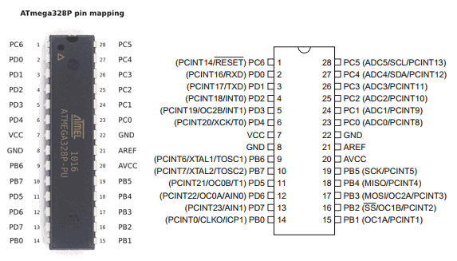

**Fig.3.2 ATmega48P/88P/168P/328P Microcontroller Pin Configuration**

**LCD:**

In the fig.3.3 shows LCD (Liquid Crystal Display) screen is an electronic display module and find a wide range of applications. A 16x2 LCD display is very basic module and is very commonly used in various devices and circuits. These modules are preferred over [seven segments](http://www.engineersgarage.com/content/seven-segment-display) and other multi segment [LED](http://www.engineersgarage.com/content/led)s. The reasons being: LCDs are economical; easily programmable; have no limitation of displaying special & even [custom characters](http://www.engineersgarage.com/microcontroller/8051projects/create-custom-characters-LCD-AT89C51) (unlike in seven segments), [animations](http://www.engineersgarage.com/microcontroller/8051projects/display-custom-animations-LCD-AT89C51) and so on.

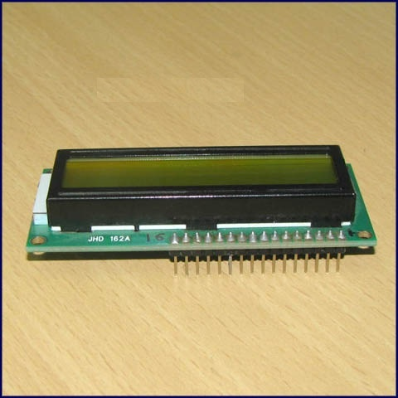

**Fig.3.3 LCD**

**Temperature Sensor LM35**

A sensor is a device that measures a physical quantity and converts it into a signal which can be read by an observer or by an instrument. These types of temperature sensors vary from simple ON/OFF thermostatic devices which control a domestic hot water system to highly sensitive semiconductor types that can control complex process control plants.

We remember from our school science classes that the movement of molecules and atoms produces heat (kinetic energy) and the more movement, the more heat is generated. **Temperature Sensors** measure the amount of heat energy or even coldness that is generated by an object or system, and can "sense" or detect any physical change to that temperature producing either an analogue or digital output.



**Fig.3.4 Temperature Sensor LM35**

**3.2 System Operation**

In this the below Fig.3. 5 shows the complete circuit diagram of the web based temperature monitoring system.

**3.2.1 Circuit diagram**

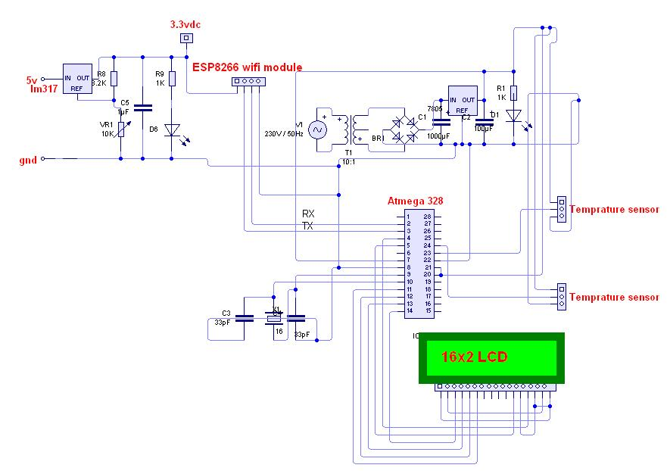**Fig.3.5 Complete Circuit Diagram**

**3.3 Hardware Designing and Implementation**

In this section explain the various components such as power supply, power supply design, rectifier unit, filter circuit etc.

**Power Supply-**

For our all IC we require 5V D.C. supply which can be generated by step down transformer, full wave bridge rectifier, filter condenser & voltage regulator IC7805.12V supply for relay is generated separately using the same procedure as shown in Fig.3.6. This supply requirement can be fulfilled in our case using the battery backup and providing recharge facility.

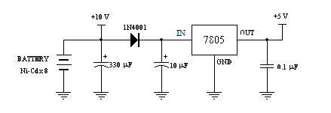

Fig.3.6 Power Supply Regulator

Power Supply Design-

Power supply is the first and the most important part of our project. For our project we require +5V regulated power supply with maximum current rating500mA.

Fig.3.7 shows basic building blocks which are required to generate regulated power supply.

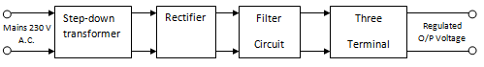

**Fig.3.7 Power Supply Design**

**Step Down Transformer-**

Step down transformer is the first part of regulated power supply. To step down the mains 230V A.C. we require step down transformer. Following are the main characteristic of electronic transformer.

1. Power transformers are usually designed to operate from source of low impedance at a single frequency.
2. It is required to construct with sufficient insulation of necessary dielectric strength.
3. Transformer ratings are expressed in volt–amp. The volt-amp of each secondary winding or windings is added for the total secondary VA. To this are added the load losses.

**Rectifier Unit-**

Rectifier unit is a circuit. which converts A.C. into pulsating D.C. Generally semi-conducting diode is used as rectifying element due to its property of conducting current in one direction only. Generally there are two types of rectifier.

1. Half wave rectifier (HWR)
2. Full wave rectifier (FWR)

In half wave rectifier only half cycle of mains A.C. is rectified so its efficiency is very poor. So we use full wave centre tap type rectifier, in which four diodes are used. In each half cycle, one diodes conduct at a time and we get maximum efficiency at o/p. Following are the main advantages and disadvantages of a full-wave centre tap type rectifier circuit.

**Advantages:**

1. We get natural ground as compared to bridge type derived from diodes bridge
2. Only two diodes required
3. Efficiency is 82 % same as bridge type.

**Disadvantages:**

1. PIV rating of diodes is 2 Vm.

**Filter Circuit-**

Generally a rectifier is required to produce pure D.C. supply for using at various places in the electronic circuit. However, the o/p of rectifier has pulsating character i.e. if such a D.C. is applied to electronic circuit it will produce a hum i.e. it will contain A.C. and D.C. components. The A.C. components are undesirable and must be kept away from the load. To do so a filter circuit is used which removes (or filters out) the A.C. components reaching the load. Obviously a filter circuit is installed between rectifier and voltage regulator. In our project we use capacitor filter because of its low cost, small size and little weight and good characteristic. Capacitors are connected in parallel to the rectifier o/p because it passes A.C. but does not pass D.C. at all.

**Three terminal voltage regulators-**

A voltage regulator is a circuit that supplies constant voltage regardless of change in load current. IC voltage regulators are versatile and relatively cheaper. The 7800 series consists of three terminal positive voltage regulators. These ICs are designed as fixed voltage regulator and with adequate heat sink, can deliver o/p current in excess of 1A. These devices do not require external component. This IC also has internal thermal overload protection and internal short circuit and current limiting protection. For our project we use 7805 voltage regulator IC as shown in Fig.3.8.

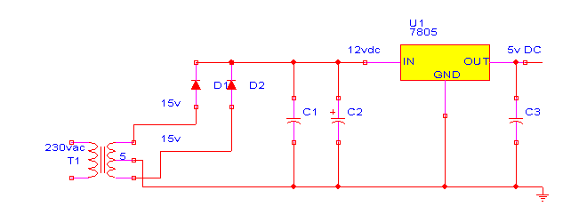

**Fig.3.8 Power Supply**

**Design of Step down Transformer-**

The following information must be available to the designer before he commences for the design of transformer.

* 1. Power Output
  2. Operating Voltage
  3. Frequency Range
  4. Efficiency and Regulation

**Size of core-**

Size of core is one of the first considerations in regard of weight and volume of transformer. This depends on type of core and winding configuration used. Generally following formula is used to find area or size of core.

$A_{i}=\sqrt{\frac{P}{0.87}}$ (1)

Ai = Area of cross – section in Sq. cm. and

P1 = Primary voltage

In transformer P1 = P2

For our project we required +5V regulated output. So transformer secondary rating is 12V, 500mA.

So secondary power wattage is,

P2= 12 x 500 x 10-3w

P2=6w

So,

∆√ (2)

Ai= 2.62

Generally 10% of area should be added to core to accommodate all turns for low Iron losses and compact size.

So

Ai = 2.88

**Turns per volt-**

Turns per volt of transformer are given by relation

Turns / Volt = 10000/4.44 FBm Ai

Here,

F is the frequency in Hz

Bm is flux density in Web/m2

Ai is net area of cross section.

Following table gives the value of turns per volt for 50 Hz frequency.

|  |  |  |  |  |  |
| --- | --- | --- | --- | --- | --- |
| Flux density  Web/m2 | 1.14 | 1.01 | 0.91 | 0.83 | 0.76 |
| Turns per volt | 40/Ai | 45/Ai | 50/Ai | 55/Ai | 60/Ai |

Generally lower the flux density better be quality of transformer.

For project for 50 Hz the turns per Volt for 0.91 Web/m2 from above table.

Turns per Volt = 50 / Ai (3)

= 50 /2.88

≅ 17

for Primary winding = 220 x 17 = 3800.

& for Secondary winding= 12 x 17 = 204.

**Wire size-**

As stated above size depends upon the current to be carried out by the winding, which depends upon current density of 3.1 A/mm2. For less copper losses 1.6 A/mm2 or 2.4 A/mm2 may be used. Generally even size gauge of wire are used.

**Rectifier Design-**

R.M.S. Secondary voltage at secondary of transformer is 12V.

So, maximum voltage Vm across Secondary is

= Rms. Voltage x √2 (4)

= 12 x √2

= 16.97

D.C. O/p Voltage at rectifier O/p is

Vdc= 2vm/ π (5)

# =2x16.97/π

# = 10.80 V

PIV rating of each diode is,

##### PIV= 2Vm. (6)

= 2 x 16.97

= 34V

& maximum forward current which flow from each diode is 500mA.

So from above parameter we select diode IN 4007 from diode selection manual.

**Design of Filter Capacitor-**

Formula for calculating filter capacitor is,

C=1/4 √3rFRL

r = ripple present at o/p of rectifier (maximum 0.1 for full wave rectifier.)

F= frequency of mains A.C.

RL = I/p impedance of voltage regulator IC

C= 1/4√3 x 0.1 x 50 x 28(7)

= 1030 μf

**≅**1000 μf

And voltage rating of filter capacitor is double of Vdc i.e. rectifier o/p which is 20V. So we choose 1000 μf / 25V filter capacitor as shown in Fig.3.9.



**Fig.3.9 Capacitor**

**IC 7805 (Voltage Regulator IC)-**

**Specifications-**

* Available o/p D.C. Voltage= + 5V
* Line Regulation= 0.03
* Load Regulation= 0.5
* VIN maximum= 35 V
* Ripple Rejection= 66-80 (db)

**Selection for current limiting resistance for LED-**

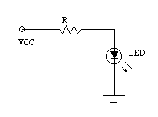

**Fig 3.10 LED**

### As o/p of micro controller is equal to supply voltage i.e. +5v dc if we directly connected LED to micro controller then very high current flowing through it because internal resistance of led is very small about 5 to 8 ohm so it is possibility to damage LED so we place current limiting resistance R in series with diode the value of this resistance is calculated.

From ohms low,

V= R I (8)

Where I= If safe forward current flowing through LED which normal intensity glow and this value near about 8 to 10 mA

∴ 5 = R x 8mA

∴R = 625 Ω

So we select near about value 680Ω

**3.4 Atmega 328 Microcontroller**

The Fig 3.11 shows ATmega48P/88P/168P/328P is a low-power CMOS 8-bit microcontroller based on the AVR enhanced RISC architecture in[14]. By executing powerful instructions in a single clock cycle, the ATmega48P/88P/168P/328P achieves throughputs approaching 1 MIPS per MHz allowing the system designed to optimize power consumption versus processing speed.

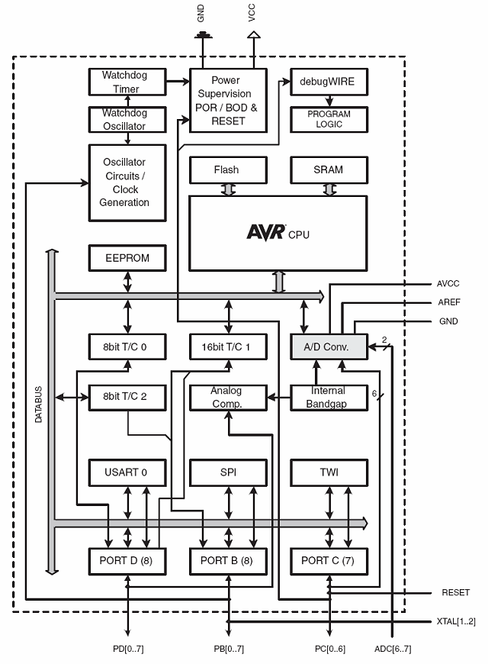

**Fig 3.11 Atmega328 Microcontroller**

The AVR core combines a rich instruction set with 32 general purpose working registers. All the 32 registers are directly connected to the Arithmetic Logic Unit (ALU), allowing two independent registers to be accessed in one single instruction executed in one clock cycle. The resulting architecture is more code efficient while achieving throughputs up to ten times faster than conventional CISC microcontrollers. The ATmega48P/88P/168P/328P provides the following features: 4K/8K/16K/32K bytes of In-System Programmable Flash with Read-While-Write capabilities, 256/512/512/1K bytes EEPROM, 512/1K/1K/2K bytes SRAM, 23 general purpose I/O lines, 32 general purpose working registers, three flexible Timer/Counters with compare modes, internal and external interrupts, a serial programmable USART, a byte-oriented 2-wire Serial Interface, an SPI serialport, a 6-channel 10-bit ADC (8 channels in TQFP and QFN/MLF packages), a programmable Watchdog Timer with internal Oscillator, and five software selectable power saving modes. The Idle mode stops the CPU while allowing the SRAM, Timer/Counters, USART, 2-wire Serial Interface, SPI port, and interrupt system to continue functioning. The Power-down mode saves the register contents but freezes the Oscillator, disabling all other chip functions until the next interruptor hardware reset. In Power-save mode, the asynchronous timer continues to run, allowing the user to maintain a timer base while the rest of the device is sleeping. The ADC Noise Reduction mode stops the CPU and all I/O modules except asynchronous timer and ADC, to minimize switching noise during ADC conversions. In Standby mode, the crystal/resonator Oscillator is running while the rest of the device is sleeping. This allows very fast start-up combined with low power consumption. The device is manufactured using Atmel’s high density non-volatile memory technology. The On-chip ISP Flash allows the program memory to be reprogrammed In-System through an SPI serial interface, by a conventional non-volatile memory programmer, or by an On-chip Boot program running on the AVR core.

The Boot program can use any interface to download the application program in the Application Flash memory. Software in the Boot Flash section will continue to run while the Application Flash section is updated, providing true Read-While-Write operation. By combining an 8-bit RISC CPU with In-System Self-Programmable Flash on a monolithic chip, the Atmel ATmega48P/88P/168P/328P is a powerful microcontroller that provides a highly flexible and cost effective solution to many embedded control applications.

**Features**

**1.High Performance, Low Power AVR® 8-Bit Microcontroller**

**2.Advanced RISC Architecture**

_131 Powerful Instructions – Most Single Clock Cycle Execution

– 32 x 8 General Purpose Working Registers

– Fully Static Operation

– Up to 20 MIPS Throughput at 20 MHz

– On-chip 2-cycle Multiplier

**3.High Endurance Non-volatile Memory Segments**

– 4/8/16/32K Bytes of In-System Self-Programmable Flash program memory

(ATmega48P/88P/168P/328P)

– 256/512/512/1K Bytes EEPROM (ATmega48P/88P/168P/328P)

– 512/1K/1K/2K Bytes Internal SRAM (ATmega48P/88P/168P/328P)

– Write/Erase Cycles: 10,000 Flash/100,000 EEPROM

In-System Programming by On-chip Boot Program

**4.Peripheral Features**

– Two 8-bit Timer/Counters with Separate Prescaler and Compare Mode

– One 16-bit Timer/Counter with Separate Prescaler, Compare Mode, and Capture

Mode

– Real Time Counter with Separate Oscillator

– Six PWM Channels

**5.Special Microcontroller Features**

– Power-on Reset and Programmable Brown-out Detection

– External and Internal Interrupt Sources

**6.I/O and Packages**

– 23 Programmable I/O Line

**7.Speed Grade**:

– ATmega328P: 0 - 4 MHz @ 1.8 - 5.5V, 0 - 10 MHz @ 2.7 - 5.5V, 0 - 20 MHz @ 4.5 - 5.5V

• Low Power Consumption at 1 MHz, 1.8V, 25°C for ATmega48P/88P/168P:

– Active Mode: 0.3 mA

– Power-down Mode: 0.1 μA

– Power-save Mode: 0.8 μA (Including 32 kHz RTC)



**Fig3.12 Pin Configuration of ATmega328P**

**Pin Descriptions**

**VCC:** Digital supply voltage.

**GND:** Ground.

**Port B (PB7:0) XTAL1/XTAL2/TOSC1/TOSC2 :**

Port B is an 8-bit bi-directional I/O port with internal pull-up resistors (selected for each bit). The Port B output buffers have symmetrical drive characteristics with both high sink and source capability. As inputs, Port B pins that are externally pulled low will source current if the pull-up resistors are activated. The Port B pins are tri-stated when a reset condition becomes active, even if the clock is not running.

**Port C (PC5:0):**

Port C is a 7-bit bi-directional I/O port with internal pull-up resistors (selected for each bit). The PC5..0 output buffers have symmetrical drive characteristics with both high sink and source capability. As inputs, Port C pins that are externally pulled low will source current if the pull-up resistors are activated. The Port C pins are tri-stated when a reset condition becomes active, even if the clock is not running.

**PC6/RESET:**

If the RSTDISBL Fuse is programmed, PC6 is used as an I/O pin. Note that the electrical characteristics of PC6 differ from those of the other pins of Port C. If the RSTDISBL Fuse is unprogrammed, PC6 is used as a Reset input. A low level on this pin for longer than the minimum pulse length will generate a Reset, even if the clock is not running.

**Port D (PD7:0):**

Port D is an 8-bit bi-directional I/O port with internal pull-up resistors (selected for each bit). The Port D output buffers have symmetrical drive characteristics with both high sink and source capability. As inputs, Port D pins that are externally pulled low will source current if the pull-up resistors are activated. The Port D pins are tri-stated when a reset condition becomes active, even if the clock is not running.

**AVCC:**

AVCC is the supply voltage pin for the A/D Converter, PC3:0, and ADC7:6. It should be externally connected to VCC, even if the ADC is not used. If the ADC is used, it should be connected to VCC through a low-pass filter. Note that PC6..4 use digital supply voltage, VCC.

**AREF:**

AREF is the analog reference pin for the A/D Converter.

## 3.5 Introduction to the Arduino

Arduino is an open-source electronics prototyping platform based on flexible, easy-to use hardware and software. It’s intended for artists, designers, hobbyists, and anyone interested in creating interactive objects or environments.

Arduino can sense the environment by receiving input from a variety of sensors and can affect its surroundings by controlling lights, motors, and other actuators. The microcontroller on the board is programmed using the Arduino programming language and the Arduino Development Environment. Arduino projects can be stand-alone, or they can communicate with software running on a computer.

There are plenty of other microcontrollers available. So you may be asking, why choose the Arduino? Arduino really simplifies the process of building projects on a microcontroller making it a great platform for amateurs. You can easily start working on one with no previous electronics experience. That is what this Arduino guide is about.

In addition to Arduino’s simplicity, it is also inexpensive, cross-platform and open source. The Arduino is based on Atmel’s ATMEGA8 and ATMEGA168 microcontrollers. The plans for the modules are published under a Creative Commons license, so experienced hobbyists and professionals can make their own version of the Arduino, extending it and improving it.

 R[elatively inexperienced users can build a version of the Arduino module on a breadboard](http://www.makeuseof.com/tag/dont-spend-money-on-an-arduino-build-your-own-for-much-less/) in order to understand how it works and save a little bit of money.

## What Is Inside an Arduino?

## Although there are many different types of Arduino boards available, this manual focuses on the Arduino Uno. This is the most popular Arduino board around. So what makes this thing tick? Here are the specifications:

* Processor: 16 Mhz ATmega328
* Flash memory: 32 KB
* Ram: 2kb
* Operating Voltage: 5V
* Input Voltage: 7-12 V
* Number of analog inputs: 6
* Number of digital I/O: 14 (6 of them pwm)

The specs may seem meager compared to your desktop computer, but remember that the Arduino is an embedded device. We have a lot less to process than your desktop.

**Wi-Fi Module**

**Features**

1.802.11 b/g/n protocol

2.Wi-Fi Direct (P2P), soft-AP

3.Integrated TCP/IP protocol stack

4.Integrated TR switch, balun, LNA, power amplifier and matching network

5.Integrated PLL, regulators, and power management units

6.19.5dBm output power in 802.11b mode

7.Integrated temperature sensor

8.Supports antenna diversity

9.Power down leakage current of < 10uA

10.Integrated low power 32-bit CPU could be used as application processor



**Fig.3.13 Wi-Fi Module**

**ESP8266 Applications:**

1.Smart power plugs

2.Home automation

3.Mesh network

4.Industrial wireless control

5.Baby monitors

6.IP Cameras

7.Sensor networks

8.Wearable electronics

9.Wi-Fi location-aware devices

10.Security ID tags

11.Wi-Fi position system beacons

**3.6 PCB Designing and Fabrication**

In this explain the printed circuit board and its functions**.**

**3.6.1 Description of Printed Circuit Board**

It is called PCB in short, printed circuit pattern applied to one or both sides of an insulating base, depending upon that, that, and it is called single sided PCB or double-sided PCB.

|  |
| --- |
|  |
|  |

Conductor materials available are silver, brass, aluminum and copper; copper is most widely used which is used here also. The thickness of conducting material depends upon the current carrying capacity of the circuit.

The printed circuit board usually serves three functions:

1. It provides mechanical support to the components mounted on it.
2. It provides necessary electrical interconnection.
3. It acts as heat sink i.e. it provides a conduction path leading to removal of most of the heat generated in the circuit.

**Cu clad-**

The base of laminate is either paper of glass fiber cloth. Cu foil, which is produced by the method of electroplating, is placed on laminate and both are kept under hydraulic pressure for proper adhesive pressure for proper adhesive. These Cu clad are easily available in the market.

3.7 Types of Laminates

National Electrical Manufacturers Association (NEMA) has various grades of laminates that are obtained by different resins & filters in[10].

1.Phenol-

Phenol & Formaldehyde produce phenolic paper base laminate it has phenolic resins with proper filter. This is Brown in color & opaque. Disadvantage is poor moisture resistance.

2.Epoxy Laminates-

Epoxy paper this is also paper based but impregnated with epoxy resin, yellowish white & translucent.

Epoxy Glass: This base material has high mechanical strength and good electrical properties usually green in color & semitransparent.

There are a variety of laminates available. We have selected Fiber Glass epoxy laminate.

3.8 Fabrication of PCB

PCB fabrication includes following steps:

1. Layout of the circuit
2. Artwork designing
3. Printing
4. Etching
5. Drilling
6. Mounting of components & soldering
7. Finishing

Layout-

The layout of a PCB has to incorporate all the information on the board before one can go onto the all work preparation. Detailed circuit diagram, the design concept and the philosophy behind the equipment are very important for the layout.

Layout Scale-

Depending on the accuracy required artwork should be produced at a 1:1 or 2:1 or even 4:1 scale. The layout is best prepared on the same scale as the artwork to prevent the entire problem, which might be caused by redrawing of the layout to the artwork scale. The layout/artwork scale commonly applied is 2:1 with a 1:1 scale, no demanding single sided boards can be designed but sufficient care should be taken, particularly during the artwork preparation.

Procedure for layout preparation-

The first rule is to replace each and every PCB layout as viewed from the component side. This rule must be strictly followed to avoid confusion, which would otherwise be caused. Another important rule is not to start the designing of a layout unless an absolutely clear circuit diagram is available.

Among the components, the larger ones are placed first and the space in between is filled with smaller ones. Components requiring input/output connecting come near the connector. All components are placed in such a manner that de-soldering of other components is not necessary if they have to be replaced.

Layout sketch-

The end product of the layout designing is the pencil sketched component and conductor drawing which is caller ‘layout sketch’. It contains all information for the preparation of the network.

Component holes-

In a given PCB, most of the holes required are one particular diameter. Holes of a different are shown with a code in the actual layout sketch.

Conductor Holes-

A code can be used for the conductor with a special width.

Minimum spacing should also be provided.

A) Holes B) Conductor Widths

Standard holes Standard width, 0.5 mm

1.1 mm 1 mm

1.5 mm 2 mm

3.2 mm 4 mm

3.9 Artwork Designing

The generation of PCB artwork should be considered as the first step of the PCB manufacturing process. The importance of a perfect artwork should not be under estimated. Problems like inaccurate registration, broken annular rings or too critical spacing are often due to bad artwork. And even with the most sophisticated PCB production facilities, PCB can be made better than the quality of the artwork used.

Basic Approaches:

For ink drawing on white cardboard paper, good quality Indian ink and ink-pen set are minimum requirements. Drawing practice – drawing procedure is very at-least by 0.1 – 0.2, and solder pad locations. And conductors can easily be displaced by 0.3 – 0.5 mm

Screen Printing:

The process of screen – printing is well known to the printing industry because of its inherent capabilities of printing a wide range of inks on almost any kind of surface including glass, metal, plastic fabrics, wooer, etc.

Found their way into an extremely broad field of applications.

Screen–printing offers the advantages of wide control on the ink deposition, thickness though the selection of suitable mass density and composition. In the production of PCB’s. It is successfully employed in printing of

* Etch resists
* Plate resists
* Solder stop lacquers
* Notation printing

In its basic form, the screen-printing process is very simple. A screen fabric with uniform meshes and opening is stretched and fixed on a solid frame of metal or wood. The circuit pattern area open and the meshes in the rest of the area is closed. In the actual printing step, ink is forced by the moving squeeze through the open meshes onto the surface of the material to be printed. The ink deposition, in a magnified cross section, shows the shape of a trapezoid.

Pattern Transfer onto the Screen- There is two different methods in use, and each method has its own advantages and disadvantages.

* With the direct method, the screen is prepared, by coating a photographic emulsion directly onto the screen fabric and exposing it in the pattern area. The indirect method makes use of a separate screen process film, supported on a baking sheet. The film on its backing sheet that is there after pressed onto the screen fabric and sticks there. Finally, the backing sheet is peeled off, opening all those screen meshes, which are not covered by the film pattern.The direct method provides very durable screen stencils with a higher dimensional accuracy but the finest details are not reproduced.
* The indirect method is more suitable for smaller series and where the finest details to be reproduced. The indirect method is faster but dimensionally less accurate and the screen stencils are less durable, more sensitive to mechanical damages and interruption in printing.

Etching:

In all subtractive PCB process, etching is one of the most important steps. The final copper pattern is formed by selective removal of all the unwanted copper, which is not protected by an etching unit.

Solutions, which are used in etching process, are known as enchants.

* 1. Ferric Chloride
  2. Cupric Chloride
  3. Chromic Acid
  4. Alkaline Ammonia

Of these Ferric Chloride is widely used because it has short etching time and it can be stored for a long time. Etching of PCBs as required in modern electronic equipment production is usually done in spray type etching machines. Tank or bubble etching, in which the boards kept in tank, were lowered and fully immersed into the agitated, has almost disappeared.

Mounting of Components:

Careful mounting of components on PCB increases the reliability of assembly.

* One leads must be cleaned before they are inserted in PCB holes. Asymmetric lead bending must be avoided; the ENT leads must fit into holes properly so that they can be soldered.
* When the space is to be saved then vertical mounting is preferred. The vertical lead must have an insulating sleeve.
* Where jumper wire crosses over conductors, they must be insulted.
* For mounting of PCBs, TO5, DIP packages special jigs must be used of easy insertion.
* While mounting transistors, each lead must have insulating sleeve.

All the flat radial components such as resistors, diodes, and inductors are mounted and soldered. Then IC bases are soldered. The vertical components such as transistors, gang condenser and FET are mounted & soldered.

Soldering:

The next process after the component mounting is soldering; solder pint is achieved by heating the solder and base metal about the melting point of the solders used.

The necessary heat depends upon:

1.The nature and type of joints

2. Melting temperature of solder

3.Flux

Soldering techniques are of so many types but we are using iron soldering.

Soldering Iron:

Soldering iron consists of an insulating handle connected through a metal shaft, of a bit accurately makes contact with the component parts of the joint and solder and heats them up. The electrical heating elements are located in the hollow shank or handle to heat the bit.

Functions of the Bit:

It stores heat and convey it from the heat source to the work. It may be required to store surplus solder from the joint. It may be required to store molten solder and flux to the work.

The bit surface must be lined or wetted; this encourages flow of solder into the joint. When the surface of the work becomes wetted by solder, a continuous film of liquid metal between the bit and the work provides a path of high thermal conductivity through which heat can flow into the work piece.

Solder bit are made up of copper; this metal has good wetting properly, heat capability ad thermal conductivity. Tin-lead solder affects copper during soldering operation. Production of copper bit can be made with thick iron coating followed by Ni/Tin plating. The life of the bit is increased by a factor of 10 to 15. Solder irons are specified in terms of wattage. Depending on heat input intended for working and types of work (Continuous or individual) the choice of the solder iron can be made.

Procedure of Soldering:

The points to be joined must be cleaned first and fluxed. The hard solder iron and solder wire is applied to the work. The melted solder becomes bright and fluid. The iron must be removed after sufficient time and joint is allowed to coal & finishing is done.

In this chapter explain the block diagram of the proposed system, information about the microcontroller, arduino toolkit, system operations, Hardware designing and implementation and

PCB designing etc. Then the next chapter is to be conclusion.

# 3.10 Relay Circuit

# 

**Fig 3.14 Relay Circuit**

**Resistor**

Resistor is a passive component used to control current in a circuit. Its resistance is given by the ratio of voltage applied across its terminals to the current passing through it. Thus a particular value of resistor, for fixed voltage, limits the current through it. They are omnipresent in electronic circuits.

The different value of resistances are used to limit the currents or get the desired voltage drop according to the current-voltage rating of the device to be connected in the circuit. For example, if an [LED](http://engineersgarage.com/content/led) of rating 2.3V and 6mA is to be connected with a supply of 5V, a voltage drop of 2.7V (5V-2.3V) and limiting current of 6mA is required. This can be achieved by providing a resistor of 450 connected in series with the LED.Resistors can be either fixed or variable. The low power resistors are comparatively smaller in size than high power resistors. The resistance of a resistor can be estimated by their colour codes or can be measured by a multimeter. There are some non linear resistors also whose resistance changes with temperature or light. Negative temperature coefficient (NTC), positive temperature coefficient (PTC) and light dependent resistor ([LDR](http://engineersgarage.com/content/ldr)) are some such resistors. These special resistors are commonly used as sensors. Read and learn about internal structure and working of a [resistor](http://www.engineersgarage.com/insight/how-resistor-works).

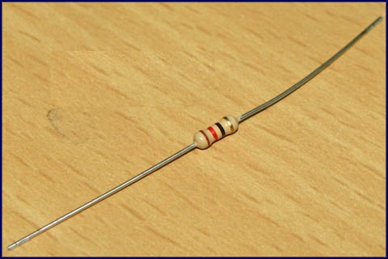

**Fig 3.15 Resistor**

# LED

**Light emitting diodes** (**LEDs**) are semiconductor light sources. The light emitted from **LED**s varies from visible to infrared and ultraviolet regions. They operate on low voltage and power. LEDs are one of the most common electronic components and are mostly used as indicators in circuits. They are also used for luminance and optoelectronic applications.

Based on semiconductor diode, LEDs emit photons when electrons recombine with holes on forward biasing. The two terminals of LEDs are anode (+) and cathode (-) and can be identified by their size. The longer leg is the positive terminal or anode and shorter one is negative terminal.

The forward voltage of LED (1.7V-2.2V) is lower than the voltage supplied (5V) to drive it in a circuit. Using an LED as such would burn it because a high current would destroy its p-n gate. Therefore a current limiting resistor is used in series with LED. Without this resistor, either low input voltage (equal to forward voltage) or PWM (pulse width modulation) is used to drive the LED. Get details about internal structure of a [LED](http://www.engineersgarage.com/insight/how-led-works).

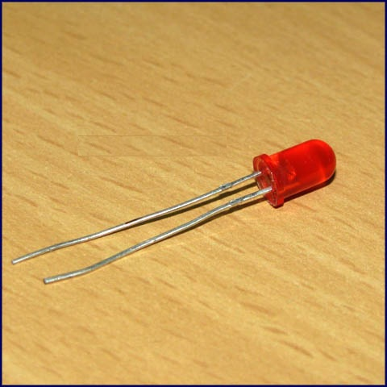

**Fig 3.16 LED**

# LDR

An LDR (Light dependent resistor), as its name suggests, offers resistance in response to the ambient light. The resistance decreases as the intensity of incident light increases, and vice versa. In the absence of light, LDR exhibits a resistance of the order of mega-ohms which decreases to few hundred ohms in the presence of light. It can act as a sensor, since a varying voltage drop can be obtained in accordance with the varying light. It is made up of cadmium sulphide (CdS).

An LDR has a zigzag cadmium sulphide track. It is a bilateral device, *i.e.*, conducts in both directions in same fashion.

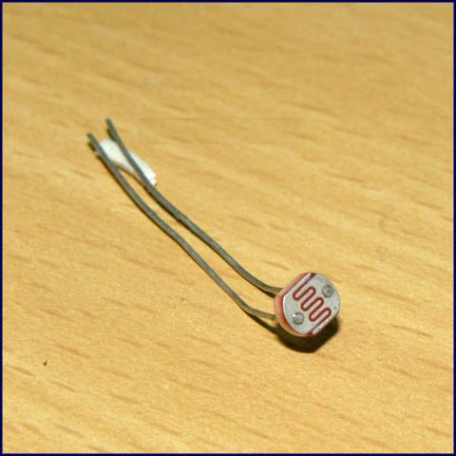

**Fig 3.17 LDR**

# Transistor BC547

**BC547** is an NPN bi-polar junction transistor. A transistor, stands for transfer of resistance, is commonly used to amplify current. A small current at its base controls a larger current at collector & emitter terminals. **BC547** is mainly used for amplification and switching purposes. It has a maximum current gain of 800. Its equivalent transistors are BC548 and BC549.

The transistor terminals require a fixed DC voltage to operate in the desired region of its characteristic curves. This is known as the biasing. For amplification applications, the transistor is biased such that it is partly on for all input conditions. The input signal at base is amplified and taken at the emitter. BC547 is used in common emitter configuration for amplifiers. The voltage divider is the commonly used biasing mode. For switching applications, transistor is biased so that it remains fully on if there is a signal at its base. In the absence of base signal, it gets completely off.

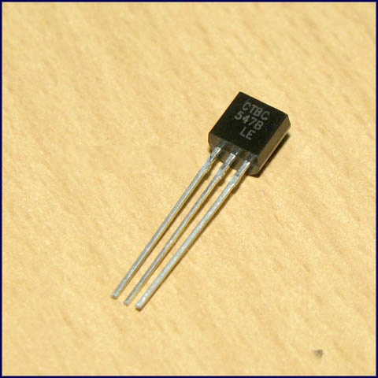

**Fig 3.18 Transistor B457**

**Relay Switch**

**Relay** is an electromagnetic device which is used to isolate two circuits electrically and connect them magnetically. They are very useful devices and allow one circuit to switch another one while they are completely separate. They are often used to interface an electronic circuit (working at a low voltage) to an electrical circuit which works at very high voltage. For example, a relay can make a 5V DC battery circuit to switch a 230V AC mains circuit. Thus a small sensor circuit can drive, say, a fan or an electric bulb.

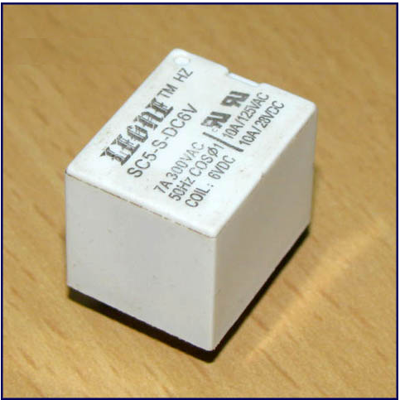

**Fig 3.19 Relay Switch**

A **relay switch**can be divided into two parts: input and output. The input section has a coil which generates magnetic field when a small voltage from an electronic circuit is applied to it. This voltage is called the operating voltage. Commonly used relays are available in different configuration of operating voltages like 6V, 9V, 12V, 24V etc. The output section consists of contactors which connect or disconnect mechanically.

**Pin Diagram:**

[Relay](http://www.engineersgarage.com/electronic-components/relays) is one of the most important electromechanical devices highly used in industrial applications specifically in automation. A relay is used for electronic to electrical interfacing i.e. it is used to switch on or off electrical circuits operating at high AC voltage using a low DC control voltage. A relay generally has two parts, a coil which operates at the rated DC voltage and a mechanically movable switch. The electronic and electrical [circuits](http://www.engineersgarage.com/electronic-circuits) are electrically isolated but magnetically connected to each other, hence any fault on either side does not affects the other side.

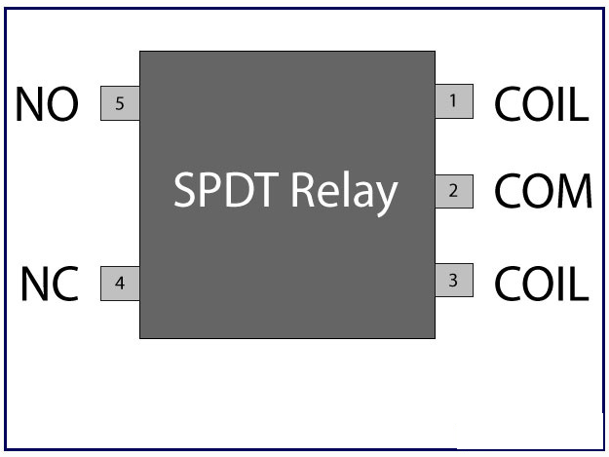

**Fig 3.20 SPDT Relay**

**Relay switch** shown in the image below consists of five terminals. Two terminals are used to give the input DC voltage also known as the operating voltage of the relay. [Relays](http://www.engineersgarage.com/electronic-components/relays) are available in different operating voltages like 6V, 12V, 24V etc. The rest of the three terminals are used to connect the high voltage AC circuit. The terminals are called Common, Normally Open (NO) and Normally Closed (NC). Relays are available in various types & categories and in order to identify the correct configuration of the output terminals, it is best to see the data sheet or manual. You can also identify the terminals using a multimeter and at times it is printed on the relay itself.

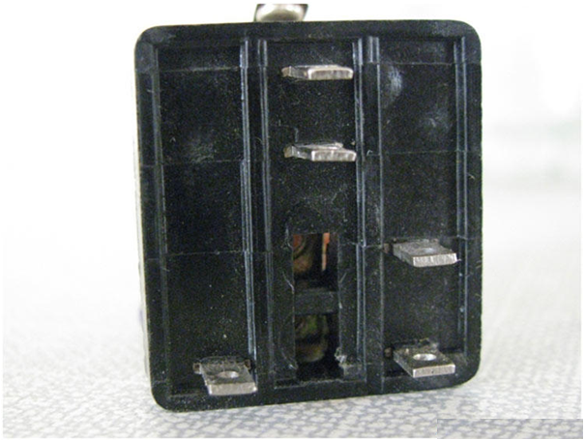

**Fig 3.21 Terminals of Relay Switch**

**CHAPTER 4**

METHODOLOGY

**4.1 Planning in phases**

Before commencement of the project it was decided to plan the project in phases so the following are the phases in which the project will be done:

* The very first phase was planning the project and getting the concepts right about the project.
* This involved lot of reading and understanding about the core concepts and the applications of our project.
* To get know about the features of various components present in the circuitry.
* Learning about various software’s like Arduino,PCB Wizard etc that will be used in our project.
* Procuring the various components required for the project.
* Preparing the PCB (printed circuit board) for our project.
* Interfacing the system with Atmega328
* Implementing the entire project.
* Testing the working of the final monitoring system.

**4.2 Installing the Arduino IDE on Windows**

#### Step 1: Download the Arduino software

#### Go to <http://arduino.cc/en/Main/Software> and download the Arduino Software for your Windows in[5].

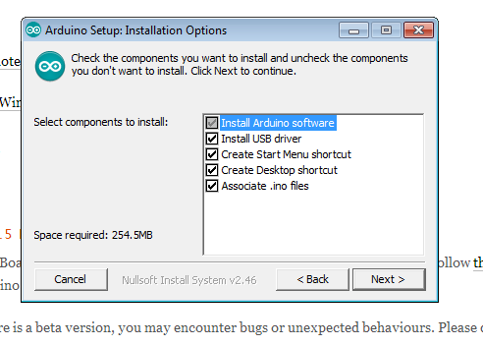

**Fig.4.1 Arduino Setup:Installation Options**

#### Step 2: Install the software in[8].

#### Install the Drivers:

* Plug in your board and wait for Windows to begin its driver installation process. After a few moments, the process will fail, despite its best efforts.
* Click on the Start Menu, and open up the Control Panel.
* While in the Control Panel, navigate to System and [Security](http://makeuseof.tradepub.com/c/pubRD.mpl?sr=oc&_t=oc:&qf=w_cybr01&ch=security). Next, click on System. Once the System window is up, open the Device Manager.
* Look under Ports (COM & LPT). You should see an open port named “Arduino UNO (COMxx)”.
* Right click on the “Arduino UNO (COMxx)” port and choose the “Update Driver Software” option.
* Next, choose the “Browse my computer for Driver software” option.
* Finally, navigate to and select the Uno’s driver file, named “ArduinoUNO.inf”, located in the “Drivers” folder of the Arduino Software download.
* Windows will finish up the driver installation from there.

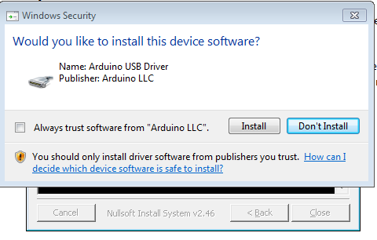

**Fig.4.2 Windows Security**

4.3Uploading Program on Arduino Board

Connect one end of your USB Cable with Computer’s USB Port and connect other end with the Arduino board.



**Fig.4.3 Connectivity of Computer and Arduino board**

### 4.5Running the Arduino Software

### Now that our software is installed and our Arduino is setup, let’s verify everything is working. The easiest way to do this is by using the “Blink” sample application.

### 1 – Open the Arduino Software by Double-clicking the Arduino Application (./arduino on Linux).

2 – Make sure the board is still connected to your computer.

3 – Open the LED blink example sketch: *File > Examples > 1.Basics > Blink*. You should see the code for the application open and it should look like this:

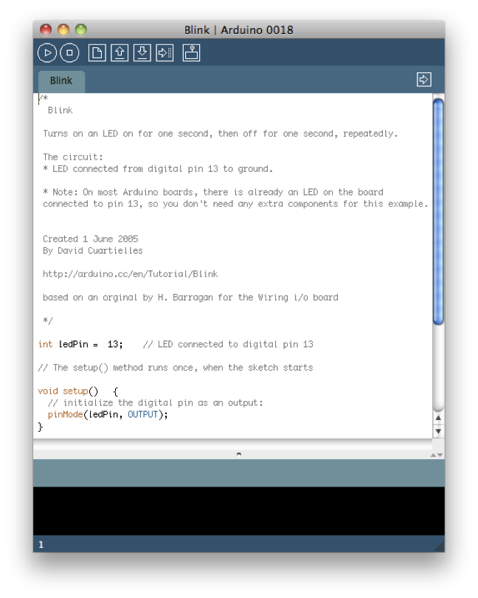

**Fig.4.4 Blink Arduino**

4 – You’ll need to select the entry in the *Tools > Board* menu that corresponds to your Arduino. Select the Arduino Uno Option.

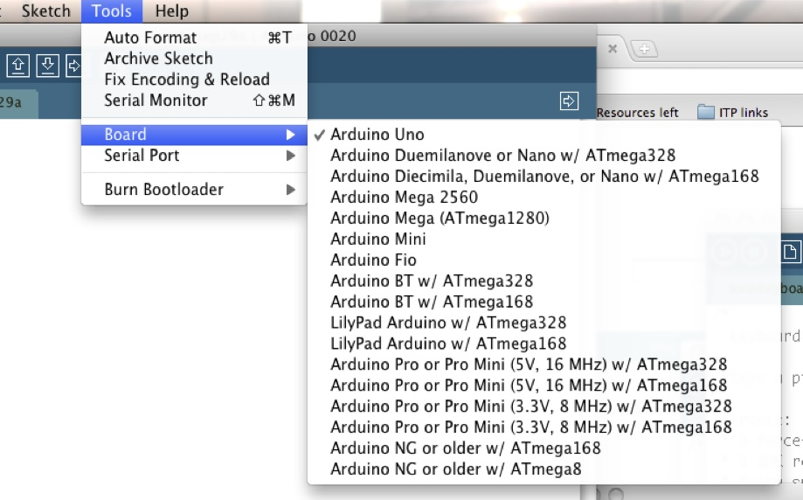

**Fig.4.5 Selecting Board**

5 – Select the serial device of the Arduino board from the *Tools > Serial Port* menu. On Windows, This is likely to be COM3 or higher. On the Mac or on [Linux](http://makeuseof.tradepub.com/c/pubRD.mpl?sr=oc&_t=oc:&qf=w_linu01&ch=linux), this should be something with ‘/dev/tty.usbmodem ‘ in it.

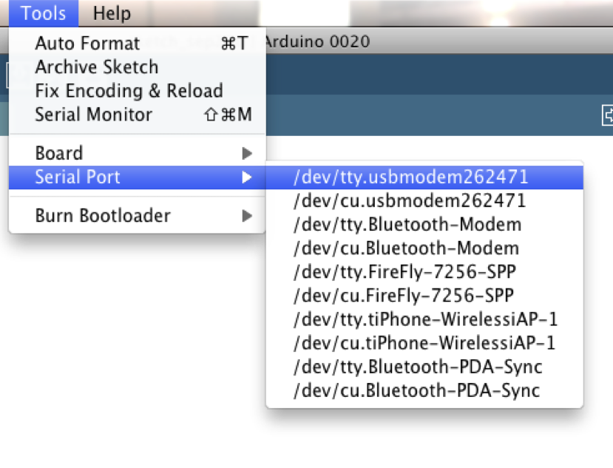

**Fig.4.6 Selecting Port**

6 – Now, simply click the “Upload” button in the environment. Wait a few seconds – you should see the RX and TX LEDs on the Arduino flashing. If the upload is successful, the message “Done uploading.” will appear in the status bar.A few seconds after the upload finishes, you should see the pin 13 (L) LED on the board start to blink. If it does, congratulations! You’ve got your Arduino up and running.

**4.3 Coding**

#include <Arduino.h>

#include <SoftwareSerial.h>

#include <ESP8266_Simple.h>

#define ESP8266_SSID "amit"

#define ESP8266_PASS "amit1234"

#include <LiquidCrystal.h>

// initialize the library with the numbers of the interface pins

LiquidCrystal lcd(4, 5, 6, 7, 8, 9);

ESP8266_Simple wifi(2,3);

const int Relay1 = 13; // choose the pin for the relay

const int Relay2 = 12; // choose the pin for the relay2

const int led=10;

void setup()

{

pinMode(Relay1, OUTPUT);

pinMode(Relay2, OUTPUT);

pinMode(led, OUTPUT);

digitalWrite(Relay1, HIGH);

digitalWrite(Relay2, HIGH);

digitalWrite(led, LOW);

Serial.begin(9600); // Reduce this if your Arduino has trouble talking so fast

Serial.println("ESP8266 Demo Server Sketch");

wifi.begin(115200);

wifi.setupAsWifiStation(ESP8266_SSID, ESP8266_PASS, &Serial);

static ESP8266_HttpServerHandler myServerHandlers[] = {

{ PSTR("GET /TEMP1"), httpTEMP1 },

{ PSTR("GET /TEMP2"), httpTEMP2 },

{ PSTR("GET /Hetter"), httpHetter },

{ PSTR("GET /fan"),httpFan},

{ PSTR("GET "), http404}

};

wifi.startHttpServer(80, myServerHandlers, sizeof(myServerHandlers), 250, &Serial);

Serial.println("( Now you can use your web browser to hit the IP address above. )");

digitalWrite(led, HIGH);

// A blank line just for debug formatting

Serial.println();

lcd.begin(16, 2);

lcd.setCursor(0,0);

lcd.print("Temprature Monitoring ");

lcd.setCursor(0,1);lcd.print("using IOT ");delay(1000);

delay(200);

}

void loop()

{

wifi.serveHttpRequest();

return;

}

unsigned long httpTEMP1(char *buffer, int bufferLength)

{

// empty the buffer

memset(buffer,0,bufferLength);

strncpy_P(buffer, PSTR("<h1>The temprature is</h1><p>temprature is: "), bufferLength-strlen(buffer));

ultoa( temprature1() ,buffer+strlen(buffer),10);

strncpy_P(buffer+strlen(buffer), PSTR("</p>"), bufferLength-strlen(buffer));

return ESP8266_HTML | 200;

}

unsigned long httpTEMP2(char *buffer, int bufferLength)

{

// empty the buffer

memset(buffer,0,bufferLength);

strncpy_P(buffer, PSTR("<h1>The temprature is</h1><p>temprature is: "), bufferLength-strlen(buffer));

ultoa( temprature2() ,buffer+strlen(buffer),10);

strncpy_P(buffer+strlen(buffer), PSTR("</p>"), bufferLength-strlen(buffer));

return ESP8266_HTML | 200;

}

unsigned long temprature1()

{

int sensorValue1 = analogRead(A0);

int voltage1 = ((sensorValue1* (5.0 / 1023.0))*100)+2;

return voltage1;

}

unsigned long temprature2()

{

int sensorValue1 = analogRead(A1);

int voltage1 = ((sensorValue1* (5.0 / 1023.0))*100)+2;

return voltage1;

}

unsigned long httpHetter(char *buffer, int bufferLength)

{

static byte ledStatus = 0;

// Let's toggle the usual D13 LED

pinMode(12, OUTPUT);

if(ledStatus)

{

digitalWrite(12, LOW);

ledStatus = 0;

}

else

{

digitalWrite(12, HIGH);

ledStatus = 1;

}

// And give a report of it's new status

memset(buffer,0,bufferLength);

strncpy_P(buffer, ledStatus ? PSTR("The LOAD1 Status Is: OFF") : PSTR("The LOAD1 Status Is: ON"), bufferLength-strlen(buffer));

return ESP8266_TEXT | 200;

}

unsigned long httpFan(char *buffer, int bufferLength)

{

static byte ledStatus = 0;

// Let's toggle the usual D13 LED

pinMode(13, OUTPUT);

if(ledStatus)

{

digitalWrite(13, LOW);

ledStatus = 0;

}

else

{

digitalWrite(13, HIGH);

ledStatus = 1;

}

// And give a report of it's new status

memset(buffer,0,bufferLength);

strncpy_P(buffer, ledStatus ? PSTR("The LOAD2 Status Is: OFF") : PSTR("The LOAD2 Status Is: ON"), bufferLength-strlen(buffer));

// And return the type and HTTP response code combined with "|" (bitwise or)

// Valid types are: ESP8266_HTML, ESP8266_TEXT, ESP8266_RAW

// Valid response codes are: any standard HTTP response code (typically, 200 for OK, 404 for not found, and 500 for error)

return ESP8266_TEXT | 200;

}

// And give a report of it's new status

memset(buffer,0,bufferLength);

strncpy_P(buffer, ledStatus ? PSTR("The LIGHT Status Is: ON") : PSTR("The LIGHT Status Is: OFF"), bufferLength-strlen(buffer));

// And return the type and HTTP response code combined with "|" (bitwise or)

// Valid types are: ESP8266_HTML, ESP8266_TEXT, ESP8266_RAW

// Valid response codes are: any standard HTTP response code (typically, 200 for OK, 404 for not found, and 500 for error)

}

unsigned long http404(char *buffer, int bufferLength)

{

memset(buffer, 0, bufferLength);

strcpy_P(buffer, PSTR("<h1>Temprature Monitoring using IOT </h1>\r\n<p>Try <a href=\"/TEMP1\">/TEMP1</a>, <a href=\"/Hetter\">/Hetter</a>, <a href=\"/TEMP2\">/TEMP2</a>,<a href=\"/Fan\">/Fan</a></p>"));

return ESP8266_HTML | 404;

}

**4.4 Hardware Setup**

The LM 35 is the temperature sensor connected to AN0 port of the PIC microcontroller device. The output voltage sensor is obtained in milli volt and it amplified of the by using

IC741. The GSM modem and LCD are connected to microcontroller.

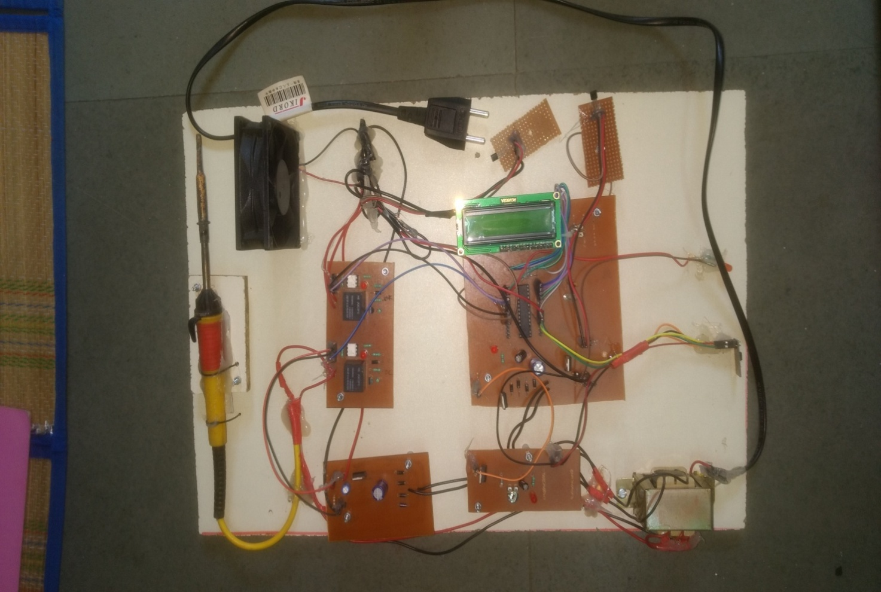

**Fig.4.7 Hardware Setup**

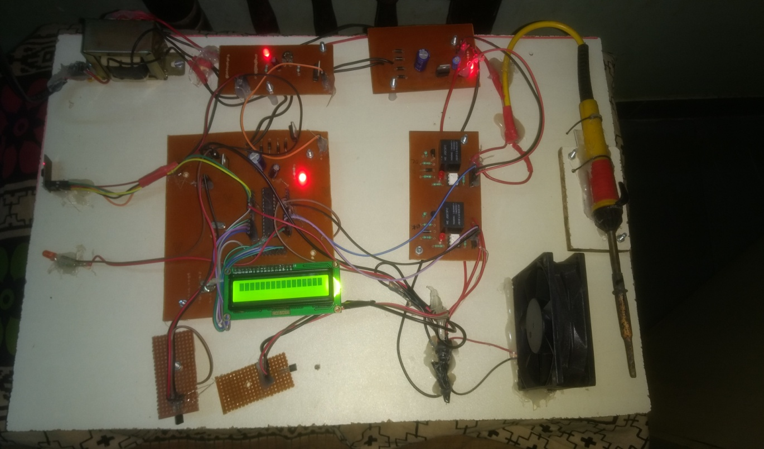

**Fig.4.8 Hardware Circuit in Power-On mode**

The fig.4.8 shows the hardware circuit in power –on mode whereas all glowing LEDs shows the power is supplied properly and LCD also display the message for indication. The Wi-Fi module also has an indicator to show power is on.

As the power is supplied through the supply of 230V AC the step down transformer is used to convert this voltage to 12V DC. The microcontroller requires only 5V DC voltage and Wi-Fi module needs only 3V DC voltage. Hence 2-way bridge rectifier and voltage regulators are used to maintain the proper voltage supply.

**4.5 Output**

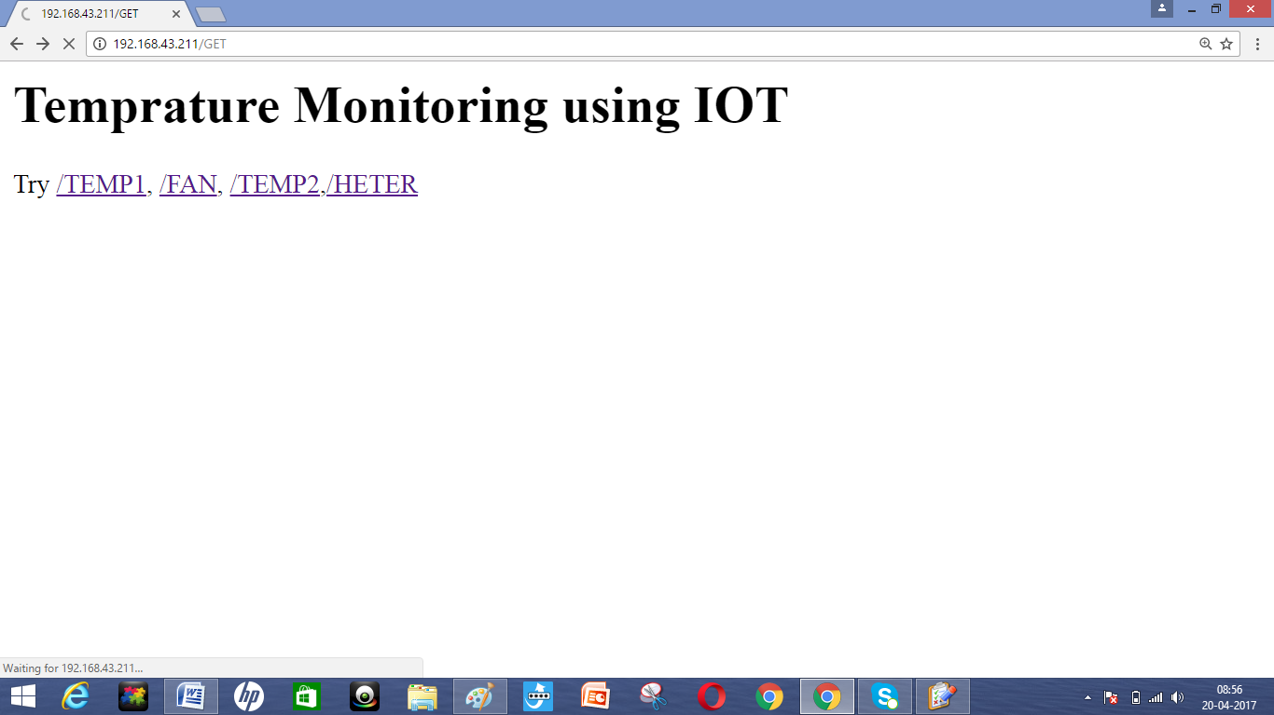

**Fig.4.9 Temperature Monitoring Webpage (Main ) Window**

The Fig.4.9 shows the Temperature Monitoring Webpage Main Window which can be accessed through the address 192.168.43.211 provided by the Wi-Fi module. When we open the webpage it shows the options - /TEMP1/FAN/TEMP2/HETER

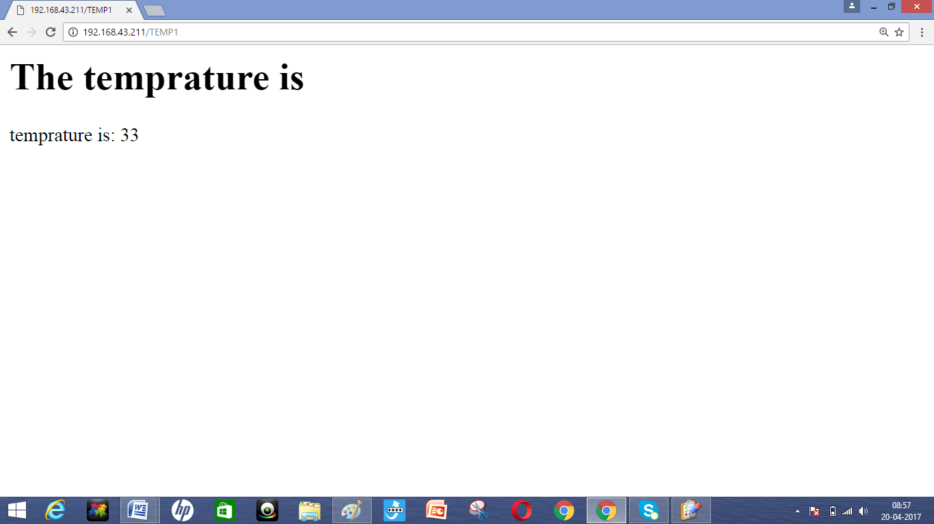

**Fig.4.10 Webpage Browser Window showing Current Room Temperature**

When an option TEMP1 in the main webpage is selected the current room temperature (i.e.33) will be displayed on the webpage window as shown in the Fig.4.10.

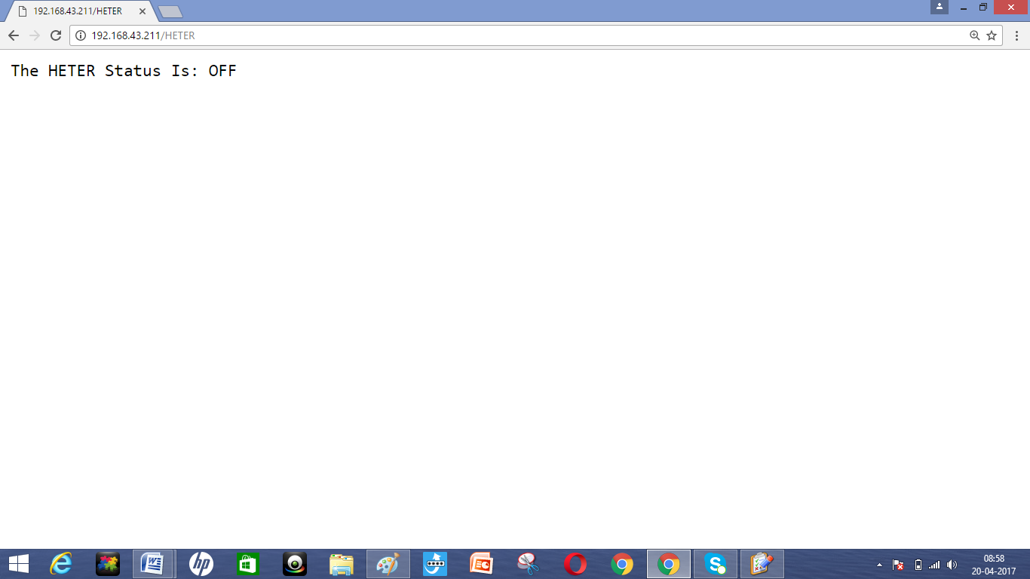

**Fig.4.11 Webpage Browser Window showing Heater Status(OFF)**

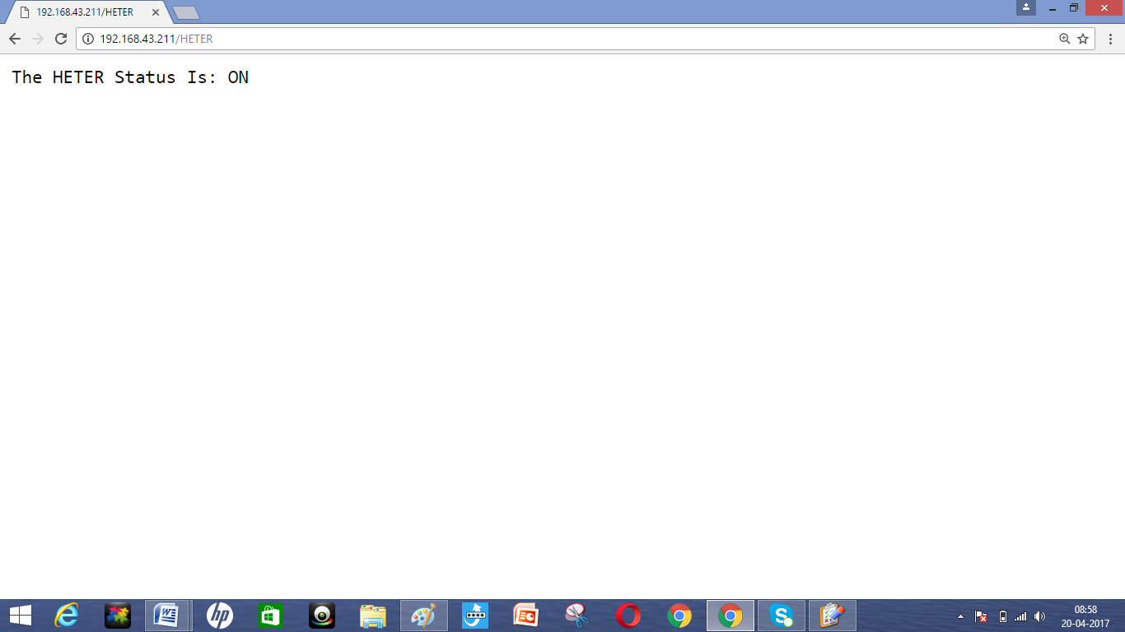

**Fig.4.12 Webpage Browser Window showing Heater Status(ON)**

When an option HETER in the webpage is selected the current status of the heater whether it is ON or OFF is displayed as shown in the Fig.4.11 and Fig.4.12. We can manually turn the heater ON or OFF by just clicking on the option HETER.

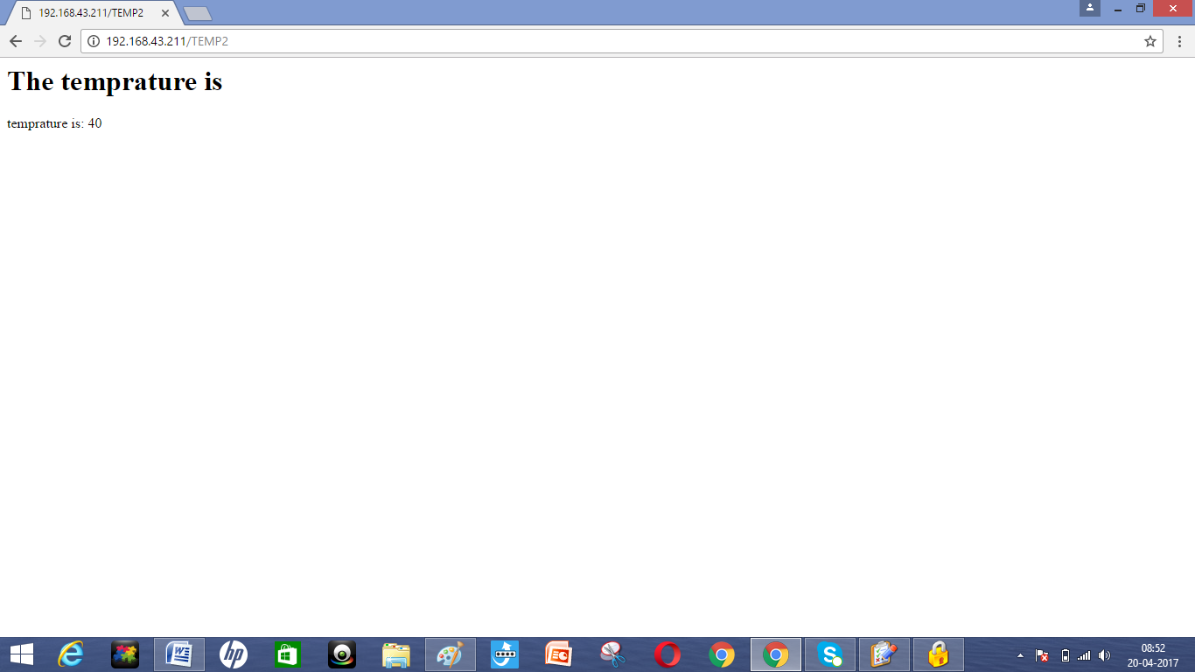

**Fig.4.13 Webpage Browser Window showing Current Heater Temperature**

When an option TEMP2 in the webpage is selected it displays the current temperature (i.e.40) of the heater as shown in the Fig.4.13.

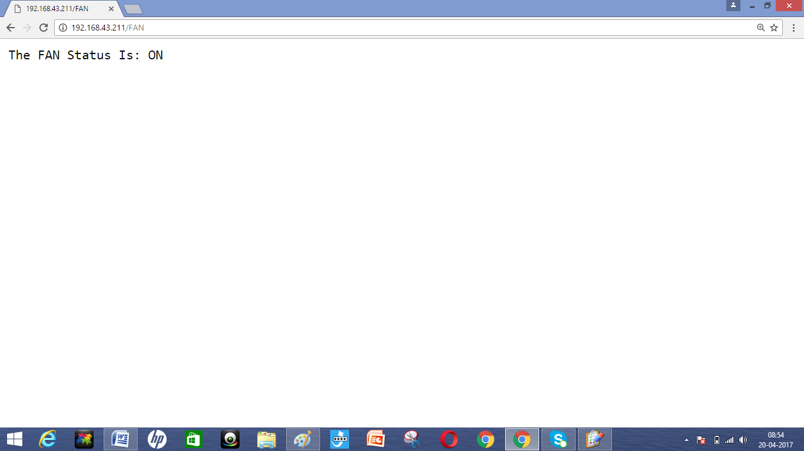

**Fig.4.14 Webpage Browser Window showing Fan status**

When an option FAN in the webpage is selected it displays the current status (i.e. ON) of the cooling fan whether it is ON or OFF .We can turn fan ON or OFF manually. The fan is used to control temperature of the heater.

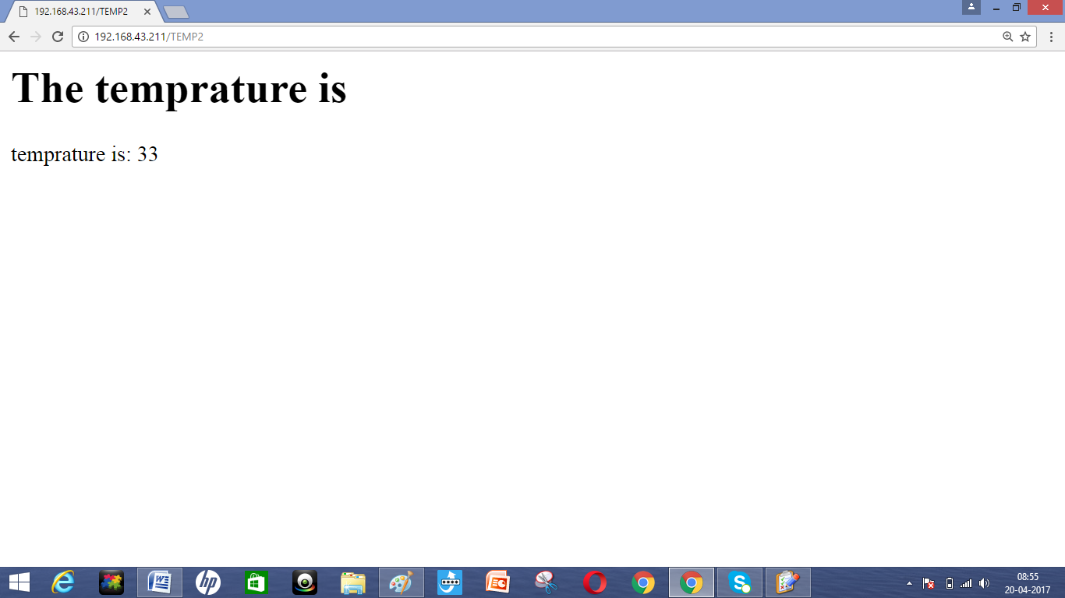

**Fig.4.15 Webpage Browser Window showing Heater Temperature after cooling**

The Fig.4.15 shows the temperature (i.e.33) of the heater after cooling when an option TEMP2 is selected.

**CHAPTER 5**

**TROUBLESHOOTING AND TESTING**

In this chapter describes the problems occurs during development process.

**5.1 Problems occurs during development**

To avoid the troubleshooting we must use new and good quality components and 60/40 type solder. The polarity of component should be strictly observed. As follows:-

* After verifying all the components on bread board and check the whole operation of the circuitry.
* After etching PCB make continuity test of all tracks if any one track is damaged then connect it through wire.
* After connecting project to battery make sure that supply to all sections are ok. When power supply at any point is available. Then troubleshooting following points:-
* Output at pin no.3 of IC 7805.
* Check IC 7805.
* See the values of decoupling capacitor.
* Check the polarity of wires connected from battery to IC 7805.
* If output from IC 7805 is less than 5V then replace that IC.
* If plc is ok then check connection between decoder and controller.
* Then the functionality and connection of relay driver, if it is not ok then replace it.
* The relay driver needs to be checked that whether it is heating or not if it occurs then replace it immediately because it is shorting.
* If all the connections and components are ok then check the power supply.

**CHAPTER 6**

**CONCLUSION**

Web-based Temperature Monitoring system designed in this project can be used for different applications such as boiling machines in industry, green houses. This system uses different devices to monitor the temperatures and it updates the temperature in the website to the receiver. Web- Based Temperature Monitoring constantly displays the current temperature in the room. With this modeling, the research will be enhanced more in developing where comparison of software architecture model is ongoing evaluations. The open-source hardware Arduino development platform has great potential for remote room temperature sensing, processing and communicating. This wireless sensor network based remote room temperature monitoring application.

Cost expenses, software used hardware involve and system programming is evaluated during the development of the future project on the designing the web based temperature monitoring system. In order to solve existing problem such as choose either to place a person to monitor the temperature, or to save on human capital by developing a system that can monitor the temperature from other places at any given time the web based temperature monitoring system that can be access anywhere anytime through the internet can be build enhancement of the project. The collected temperature data can be stored into the MYSQL database and retrieved later for analysis.

REFRENCES

[1] S.L.Y. Youling, X. Weisheng, “Design of Remote Real-TimeTemperature Monitoring System. The Eighth InternationalConference on Electronic Measurement and Instruments ICEMIProceeding 2007.

[2] B.Yan and D. Lee, “Application of RFID in Cold ChainTemperature Monitoring System”. ISECS InternationalColloquium on Computing, Communication, Control, andManagement, 2009.

[3]Wen bin Huang, Guanglong Wang, Jianglei Lu, FengqiGao,1ianhui Chen "Research of wireless sensor networks for an intelligent measurement system based on ARM", International conference on Mechatronics and Automation, pp. 1074 -1079,20 II.

[4] Yuksekkaya, B.; Kayalar, A. A.; Tosun, M.B.; Ozcan, M.K.; Alkar, A .Z.; "Research of Wireless Sensor Networks foran Intelligent Measurement System Based on ARM", IEEE Transactions on Mechatronics and Automation, Volume: 52,Issue: 3,2006 , pp. 837 - 843.

[5] Li JuGuang, Zhen Gen, Jiang ZeMing, “Embedded linux system development in details based on EP93XXARM”[M].

[6] Akyildiz, I.F., Su, W., Sankarasubramaniam, Y., Cayirci, E. Wireless sensor networks: survey. Computer Network 38(4):393-422, 2002.

[7] A.Wood, G. Virone, T. Doan, Q. Cao, L. Selavo, Y.Wu, L. Fang, Z. He, S. Lin, J.stankovic(2006) in their “ALARM-NET: Wireless Sensor Networks for Assisted-Living and Residential Monitoring”

[8] A. Goswami, T. Bezboruah and K.C. Sarma “Design of an Embedded System for Monitoring and Controlling Temperature and Light” IJEER Volume 1 Number 1 (2009) pp. 27–36

[9] "Arduino - HomePage." Arduino - HomePage. N.p., n.d. Web. 17 July 2012. <http://www.arduino.cc/>.

[10] Corke, Peter, Tim Wark, Raja Jurdak, Wen Hu, Philip Valencia, and Darren Moore. "Environmental Wireless Sensor Networks." Proceedings of the IEEE 98.11 (2010): 1903-917

[11] Culler, D., Estrin, D., Srivastava, M. Guest Editors' Introduction: Overview of Sensor Networks, Computer 37(8): 41-49, 2004.

[12] Girod, Estrin, and Pottie Srivastava. "INSTRUMENTING THE WORLD WITH WIRELESS SENSOR NETWORKS." Proceedings of the IEEE (2001): 2033-036

[13] Glazer, Brian T., Adam G. Marsh, Kevin Stierhoff, and George W. Luther. "Contents Abstract 1 Introduction 2 Literature Review 3 Wireless Sensor Technology 5 Advantages in Using ZigBee Protocol 6 Table Top 6 Building a Classroom Table Top 6 Methods Results Discussion Conclusion Recommendations." Analytica Chimica Acta 518 (2004): 93- 100

[14] Mainwaring, Alan, Joseph Polastre, Robert Szewczyk, David Culler, and John Anderson. "Wireless Sensor Networks for Habitat Monitoring." WSNA (2002)

[15] Ouyang, Y. "Evaluation of River Water Quality Monitoring Stations by Principal Component Analysis."Water Research 39.12 (2005): 2621- 635

[16] Rundel, Philip W., Eric A. Graham, Michael F. Allen, Jason C. Fisher, and Thomas C. Harmon."Environmental Sensor Networks in Ecological Research." New Phytologist 182.3 (2009): 589-607. 17